Maher Algibhah

Prof. Karen Anewalt

Writing Assignment

January 22, 2015



IDE Guide

Like thousands of developers out there, NetBeans IDE is one of the best developers. First of all, you need to know what NetBeans is. NetBeans is an IDE (Integrated Development Environment) uses to write the source code of several programming languages such as Java (SE/EE/ME/Script), C, C++, PHP, etc. NetBeans IDE lets you easily and quickly develop Java desktop, mobile, and web applications, while also providing great tools for PHP developers. This guide is designed to give you a quick start guides on how to use our NetBeans IDE to make your program using Java language. This guide is specialized for newcomers to NetBeans IDE or an experienced IDE user that is switching over from a different development environment.

* Here are some of the NetBeans IDE’s features:

Figure # 1 (NetBeans IDE application on desktop)

* 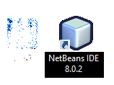NetBeans IDE is FREE and Open Source.
* Connected Developer.
* Powerful GUI Builder.
* Dynamic Language Support: such as Groovy, JavaScript, and PHP.
* Profiling and Debugging Tools.

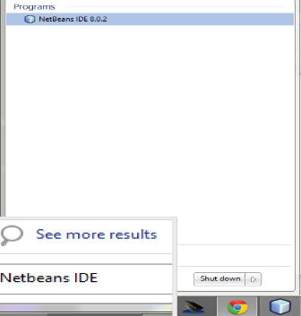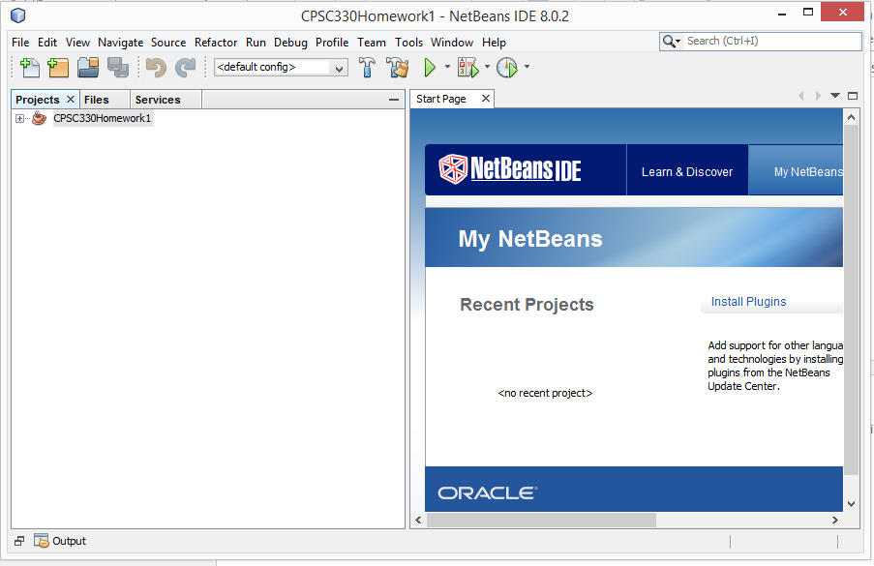After downloading NetBeans IDE to your PC or laptop and installing it, (Windows Users), you should see the NetBeans IDE application on your desktop as shown in figure (1), OR you can search for it using “Start,” as shown in figure (2). After knowing how to find the application, you need to open it, figure (3) shows the screen you will see when you open NetBeans IDE.

Figure # 2 (Searching for NetBeans IDE application using Start)

*Note:   
In order to install the NetBeans IDE, first you MUST   
download the JDK (Java Development Kit).*

Figure # 3 (screen you will see when you open NetBeans IDE)

How to Start?

First thing you need to do when you open the NetBeans application is to create your own project. An IDE project is a group of Java source files and associated information about what belongs on the class path. In the NetBeans IDE, you always work inside of a project. In other word, you cannot start writing your code unless you create your project.

* **Creating your project.**

To create a new project, from the menu, you need to click on “File” and choose “New Project…”as shown in figure 4, or simply press (Ctrl+ Shift+ N), and a new widow will show up. This window will allow you to choose the language and the type of the new project. Since this guide is for Java language, choose “Java” from the “categories”, then choose “Java application” from the “applications” and then press “Next”, as figure 5 shown.

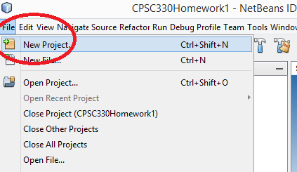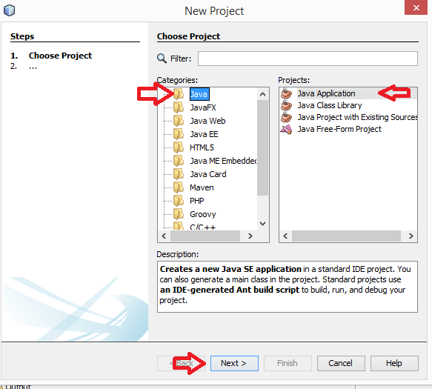

Figure # 4 (Creating a new project.)

Figure # 5 (Choosing the language and the type of the new project

Now, you need to type the name of your project, “First Project” as an example. After naming your project, you will see your project’s location’s path under the name of your project (Figure 6), but you can easily change it by pressing “Browser” button and go to where you want to save your project. In the bottom of the window (Figure 6), you will see an option about creating a main class. If you check the little square on the left of the option, it will create a main class for you and name it as same as your project name. Make sure to uncheck this option then press “Finish”. Figure 6 shows the above steps but without changing the location. (Make sure to follow the steps in order to get the same result.)

Figure # 6 (Naming a project)

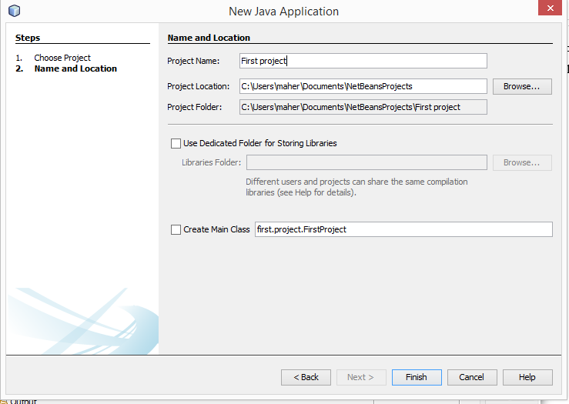

As soon as you press “Finish”, it will take a few seconds in order to create the new project that you made, and suddenly the window should disappear. Now, you should see your project’s name under “Project” which is on the left of the main window, (NetBeans IDE Window) as shown in Figure 7. That is how we create a new project.

Figure # 7 (This what you should see when you finish creating the new project)

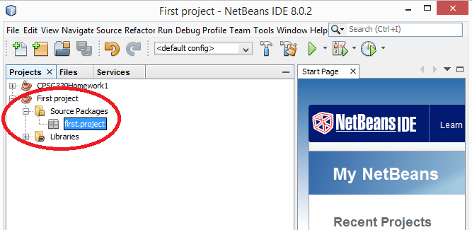

* Creating a Class.

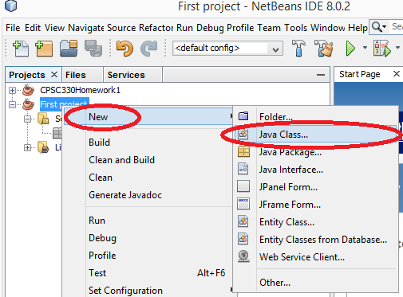Now that you finished creating your new project, you need to create a class/es to begin coding your program. In this guide, we are going to present a very simple program to give an idea on how to use our amazing IDE. First of all, you need to click right on the project that you made before, which is “First project”, then choose “New”, and then choose “Java Class…”, as figure 8 shown. A new widow will appear which allows you to type

Figure # 8 (creating a new class)

your class’ name. Let say you named it “Greeter”, then press “Finish”. Hint, always the first letter of the class’ name must be capital letter. (See figure 9).

Figure # 9 (Naming the class))

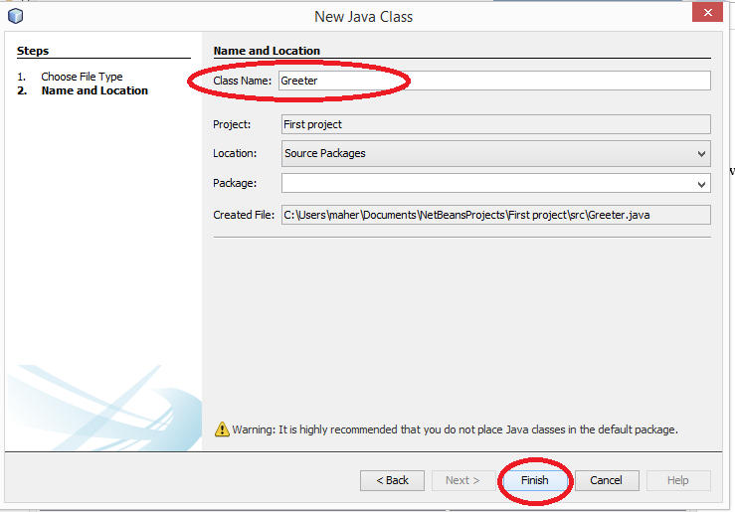

It will take a few seconds to create your new class, then the window will disappear. Now, if click on your project, “First project”, then click in the file named “Source Packages” you will see your new class “Greeter.java”. Double click on the “Greeter.java” to start writing your program’s code. (See figure 10)

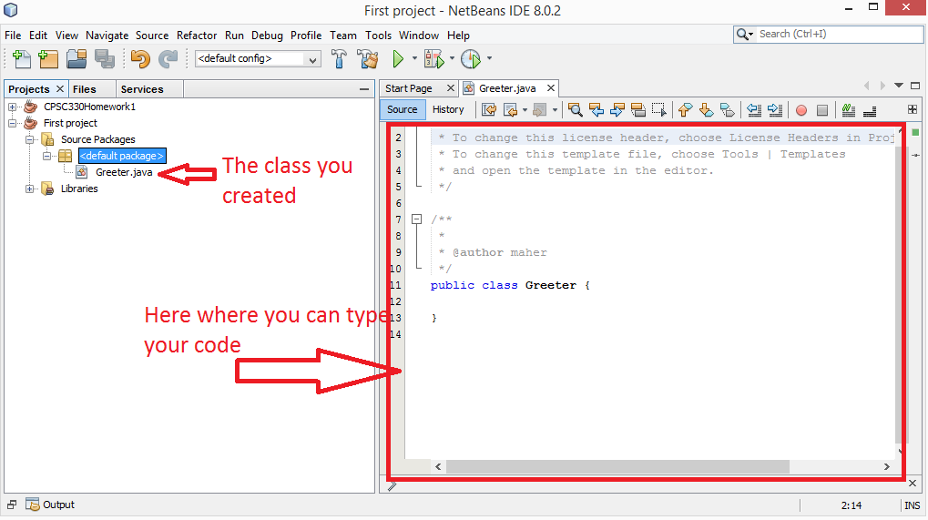

Figure # 10 (Typing your code)

* Writing your program’s code.

While writing your program’s code, you notice that NetBeans IDE is very neat and easy to follow your code. Also, it will show you the errors, and give you some options to correct them. Let’s start typing a simple code.

public class Greeter

{

//data member

private String name;

//constructor

public Greeter (String aName)

{

name= aName;

}

//method

public String sayHello()

{

return “Hello, “+ name + “!”;

}

}

Type the above code into your Greeter class that you made before. Now we need to create a new class that has a main method and name it “GreeterTester”. If you are struggling you can always go back and see how we create the first class which is “Greeter”. Open the new class, “GreeterTester” and write the below code.

public class GreeterTester

{

public static void main (String [ ] args)

{

Greeter wordGreeter = new Greeter (“ World”)  
 String greeting = worldGreeter.sayHello();

System.out.println(greeting);

}

}

* Saving the program.

Now that you finished your code, you can save your work easily by pressing (Ctrl + S) OR you can press the Icon save as shown in figure 11.

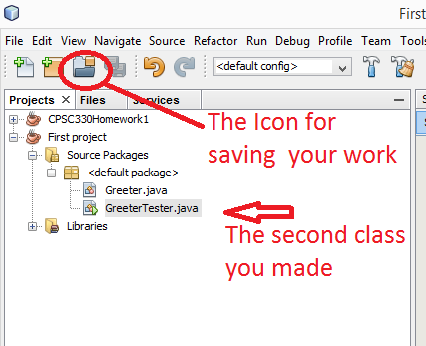

Figure # 11 (Saving your work)

* Finding and correcting syntax errors.

You can easily find you syntax errors by looking to your code until you find a red underline text or word. This red underline text/word is a syntax error. The NetBeans IDE gives you an explanation about the error when you point to the red underline text, and it helps you correct it. (See figure 12)

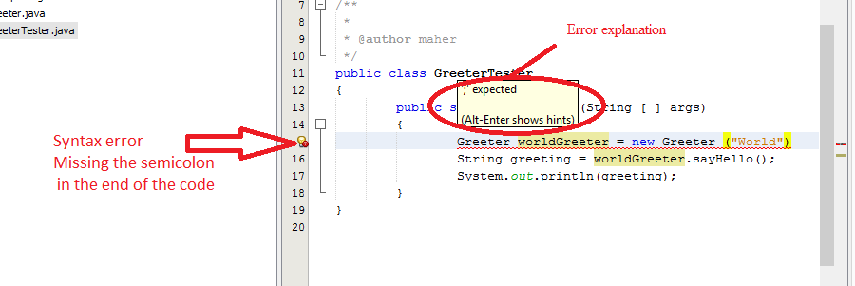

Figure # 12 (Finding syntax errors)

*Note: You need to save your work every time you make a change.*

* Compiling your program.

Simply, from the main menu, choose “Run”, and then choose “Compile File….. F9”. Note that you need to compile each class, so you will need to do this step for each class that you created. (See figure 13)

Figure # 13 (Compiling your program)

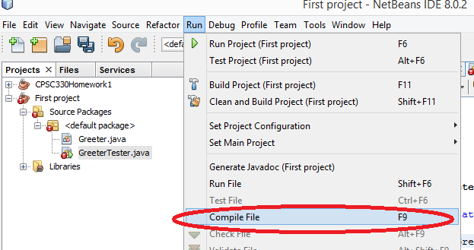

* Executing your program.

As you learn how to create your project, and your classes and compile them, now, is time to learn how to run your program. In order to execute your program, from the main menu, choose “Run”, then choose “Run Project……F6”. OR simply click the Icon Run as shown in figure 14(a and b).

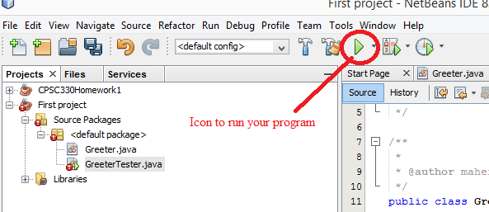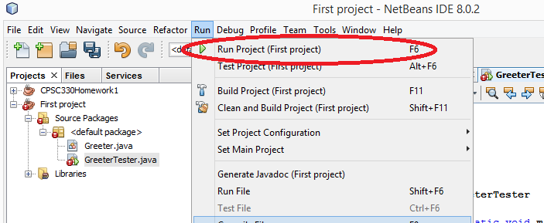

Figure # 14 b (Running your program)

Figure # 15 a (Running your program)

Finally, after running your program you should the result of your program. If you follow all the steps above you should see in the output window “Hello World!”(See figure 15).

Figure # 16 (Output result)

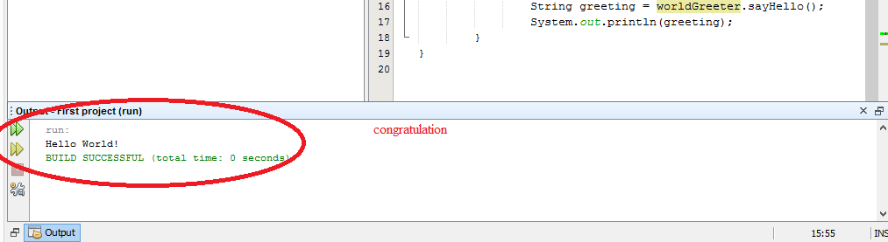

Finally, we would like to think you for reading our User’s Guide , and we hope that you like our amazing NetBeans IDE. And if you need more information, you can always visit our website <https://netbeans.org/>